Algorithm

• An algorithm is a finite set of instructions that, if followed, accomplishes a particular task.

• In addition, all algorithms must satisfy the following criteria:

(1) Input. There are zero or more quantities that are externally supplied.

(2) Output. At least one quantity is produced.

(3) Definiteness. Each instruction is clear and unambiguous.

(4) Finiteness. If we trace out the instructions of an algorithm, then for all cases, the algorithm

terminates after a finite number of steps.

(5) Effectiveness. Every instruction must be basic enough to be carried out, in principle, by a

person using only pencil and paper. It is not enough that each operation be definite as in (3); italso must be feasible

Study of Algorithms

•How to devise algorithms?

•How to validate algorithms?

•How to analyse algorithms?

•How to test a program?

How to Write an Algorithm

•There is no fix syntax for writing an Algorithm.

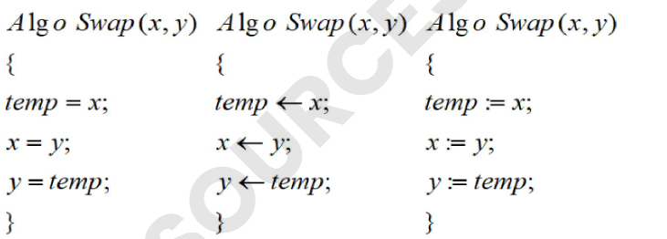

•E.g. Algorithm for swapping of two numbers:

•No data type is required in algorithm

•Extra variables are not declared in algorithm

Analysis of algorithm

• Calculating or computing all the resources that algorithm requires to solve the problem

• Name some resources:-

main memory size

time taken

no of processor,

clock speed

network speed L1.5

hard disk space

Time for input/output

OS

Hardware requirement

Space requirement

Calculating or computing the time and space requires to solve the problem in terms of input

size

Factor affecting time

complexity of an algorithm

• Data and data structure type

• Constructs used

• PL

• OS

• Processor Speed

• Hardware configuration

• Input size

Time complexity of Algorithm

• It is the total time required by an algorithm to complete the execution in terms of input Size.

Space complexity of Algorithm

• It is the total memory or space required by an algorithm to complete the execution in

terms of input size.

• Basically, both time and space complexity of an algorithm is a function that can be expressed in terms of input size